Page 4

Order Form

Item No |  |  | Description | Qty |  |  | Price
Order Total:
Total: |  |  |  |  |  |  |  |  | $
Name
Address
Phone
Signature

Warrill View State School

Method of Payment:
□ | Credit
□ | Invoice
□ | Cash

2013 -2014 School Uniforms

Children's Sizing Guide

Shirt Size | 4 | 6 | 8 | 10 | 12 | 14  www.allthatembroidery.com.au  rachel@allthatembroidery.com.au  service@allthatembroidery.com.au
Chest | 38.5 | 41 | 43.5 | 46 | 48.5 | 51
Length | 48 | 52 | 56 | 60 | 63 | 66
Jumper Size  - All Prices shown include GST..  - We can embroider the school emblem on your existing uniforms if you require.  - To order, either call us on 07 3245 4095, email at the above address or return the completed form to the school. | 4 | 6 | 8 | 10 | 12 | 14
Chest | 39 | 42.5 | 46 | 49.5 | 52 | 54.5
Length | 49 | 53 | 57 | 61 | 64 | 67
Jacket Size | 4 | 6 | 8 | 10 | 12 | 14
Chest | 39.5 | 43 | 46.5 | 50 | 53.5 | 57
Length  To find your shirt measurement, lay a shirt out flat, then measure from armpit to armpit.  For a Jumper & Jacket, lay a Jumper or Jacket out flat and measure from armpit to armpit. | 52 | 56 | 60 | 64 | 68 | 72

All That Embroidery Page 3
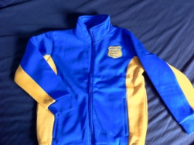

CLEARANCE

Jumper (Limited Number Available)

Full zip polar fleecy in Royal Blue with Gold Paneling.
Price: Plain $11

With Warrill View Emblem
Price: $15

Podium Warm-up Jacket
Royal Blue and Gold
100% Polyester satin backed microfiber 125 gsm, Fully lined with mesh and taffeta, Zip through hi collar styling and two front welt pockets, Adjustable Elastic cuffs, Hem with shoestring elastic and adjustable toggles, Drop tail, Contrast sleeve panel.

Price: Plain $28.60

With Warrill View Emblem
Price: $35.20

With Emblem & Name (Can use Initials if required)
Price: $41.80

Jumpers & Jackets are also available in Adult sizes Small to 3XL
Please contact for more information

Wide Brim Hat
Royal Blue Hat with Warrill View name
Price: $12.50

Shirt
Plain Gold coloured polo shirt with 40UPF (Ultraviolet Protection Factor) from JB's Wear
Price: $11

Embroidered Warrill View Gold coloured polo shirt with 40UPF (Ultraviolet Protection Factor) from JB's Wear
Price: $16.50

Extra Embroidery
Embroider the school emblem or your child's name directly onto existing uniforms.

WARRILL VIEW
EMBLEM $6.60

NAME $7.70

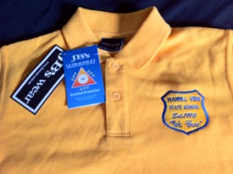

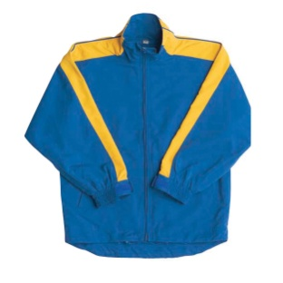

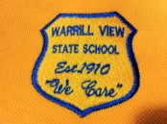

Page 2 To Order Call: 07 3245 4095
NAME

